
Sec 7.5 – Chromatic Numbers
Networks & Graphs Name:
Color in each of the following maps using 2 colors such that no two adjacent regions share the same color (each map has a chromatic number of 2)

Color in the following map using 3 colors such that no two adjacent regions share the same color. (The graph has a chromatic number of 3)

Color in the following map using 4 colors such that no two adjacent regions share the same color. (The graph has a chromatic number of 4)

You should never need more than 4 colors to color in a 2-dimensional (planar) map.
Convert the following map in to a graph (regions become vertices) and determine the chromatic number of both the graph and the map.

A
B
C
D
E

Student Worksheets Created by Matthew M. Winking at Phoenix High School SECTION 7-5 p.93

Convert the following map in to a graph (regions become vertices).
A
I
G
H
E
B
C
D
F

Determine the Chromatic number of each of the following graphs.

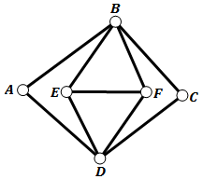

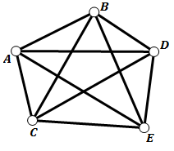

Student Worksheets Created by Matthew M. Winking at Phoenix High School SECTION 7-5 p.94

Transportation Dilemma

You are planning a trip to Elitch Gardens for your eight friends There are several people who, for various reasons, cannot ride in the same car.

Part one: Using the following information, create a graph which illustrates those people who cannot ride together. (Using Chromatic Numbers)

- Amy stole Cara's boyfriend at the last party.
- Amy wrecked Becky's car and is refusing to pay for the damages.
- Fred has been dating Amy and Ellena and telling each of them that the other girl is chasing him. Additionally, he has been telling his fellas that he has them both conned. Recently they found out about his little scam. (Amy and Ellena are still best friends).
- Cara stole Becky's cell phone and is refusing to give it back.
- Cara has been telling everyone that Ellena and Amy will talk about you behind your back if they have the chance and doesn’t like them.
- David never forgave Cara for stealing his clothes out of the boy's locker room in the seventh grade.
- David told everyone that Ellena is BORING. (Obviously this did not go over well with Ellena).
- Becky left Gary in Colorado Springs last weekend when they were camping, and Gary had to hitch-hike the entire way back to Denver.
- Ellena accidentally forgot to feed Gary's goldfish, Moby, while he was away, and it died.
- Heather has always sided with Amy and Ellena, so she is always mad at anyone who is feuding with either of the girls - EXCEPT David . They are siblings, and they always back each other up.

Graph

Part two: Determine the minimum number of cars necessary to transport everyone to the park. Assume that the seating capacity of the cars is not
a problem, and you can ride in any car.

Student Worksheets Created by Matthew M. Winking at Phoenix High School SECTION 7-5 p.95

